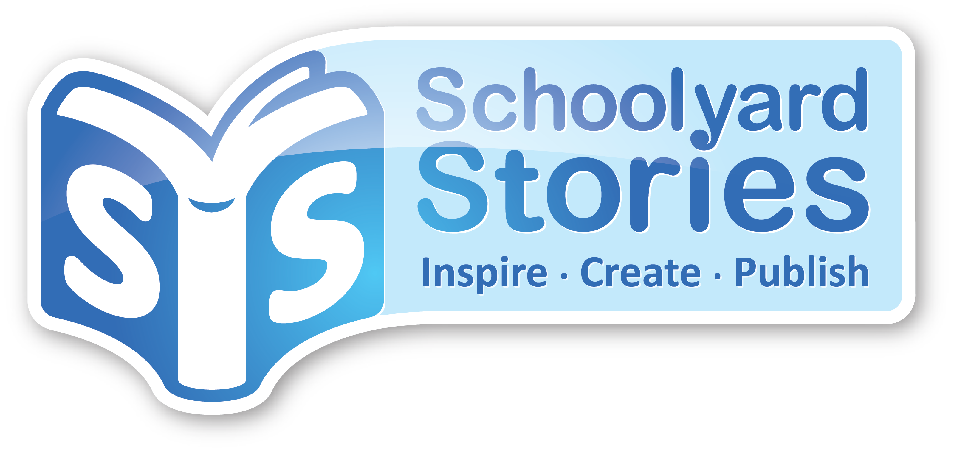
<Coordinators Name>
<School Name>
<Address>
<School Phone> <Coordinator’s Phone>

<Date>

Dear <Sponsor>;

We at <School name> are publishing a book of <short stories/recipes> created by our students. By steering clear of typically unhealthy fundraisers, our aim is to promote <literacy/healthy eating> while raising much needed funds for our school.

Being a school of <number> families we are likely to sell at least one book per family. We already have <number> pre orders and with every child represented the book will sell itself.

By making a contribution, you will help our school offset printing costs, your business will gain the goodwill generated through school sponsorship and recognition through marketing.

The book is of highest quality and lends itself to exceptional advertising space in colour on the cover or in black and white within the book. Because of the limited room available we will restrict our sponsors to the first <number 1-5> local businesses expressing interest.

We would like to offer you the opportunity to advertise in our publication. You will be shown a sample of the quality of book we will be producing.
Position Pricing is as follows:

The following is a table of suggested prices and sizes. Please adjust to suit your publication.
You may charge pre book (Cost/book column) or flat fee (Cost column).
*Make sure you delete the column you are not using.
Description Options | Advert Size | Cost/book | Cost
1. Full Colour logo Back Cover | 80mmX30mm | $0.90 | $400.00
2. Full Colour logo Back Cover | 25mmX 25mm | $0.70 | $250.00
3. B&W Ad within book | A5 | $0.40 | $300.00
4. Combination of 1 & 3 | 80X30mm & A5 | $1.20 | $500.00
5. Combination of 2 & 3 | 25X25mm & A5 | $1.00 | $600.00
6. Sole Advertising Rights | Get Creative | $2.00 | $1,500.00

Thank you for your time and consideration.
Kind Regards,

<Coordinator’s Name>
<Coordinator’s Position>

For further information on what this publication offers, visit www.schoolyardstories.com.au

